**Nama : Suryo Kartoko Arif Pamungkas**

**NIM : 1462400086**

**Kelas : B**

**Link YouTube :**

**Link githup:**

Soal 1

a. Source Code

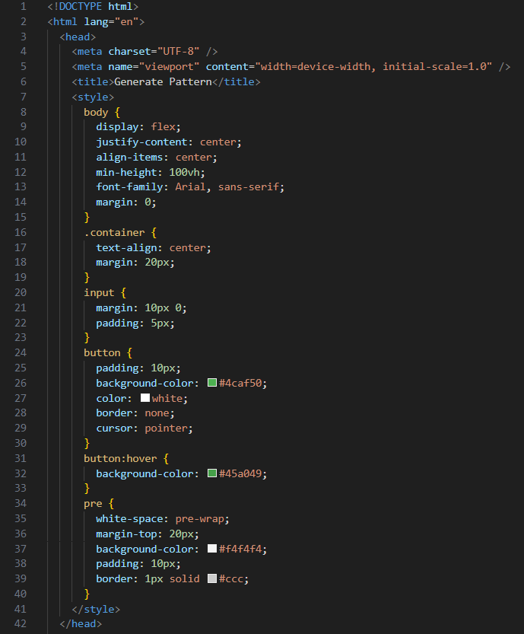

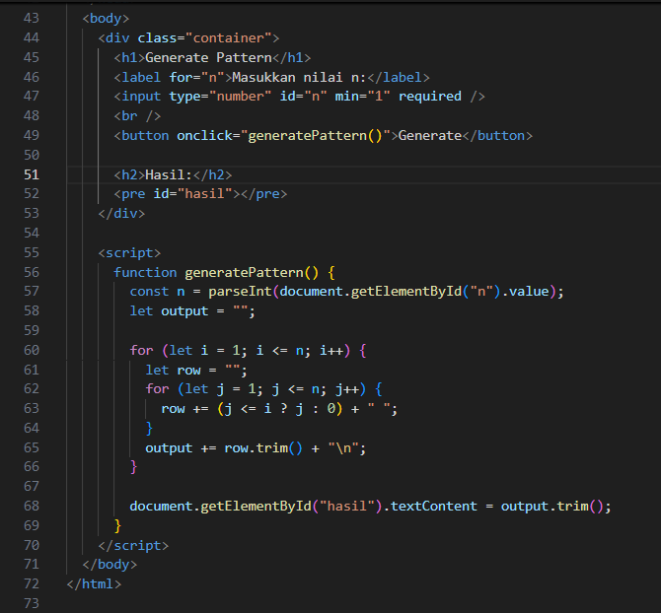

b. Screenshoot Hasil

Soal 2

a. Source Code

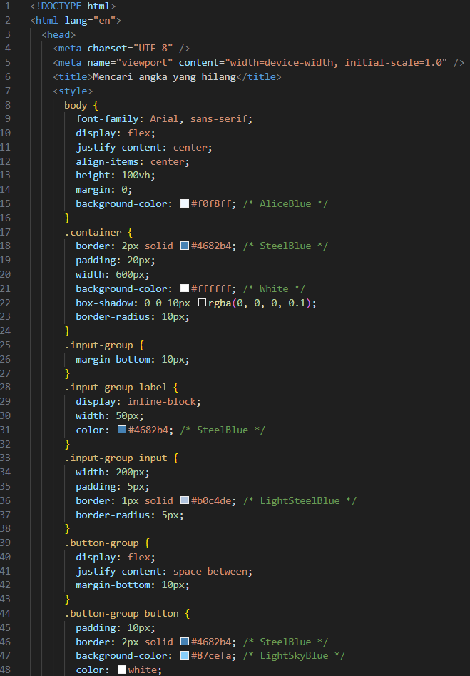

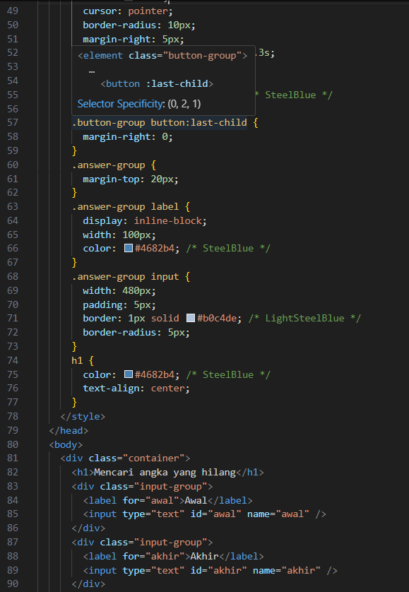

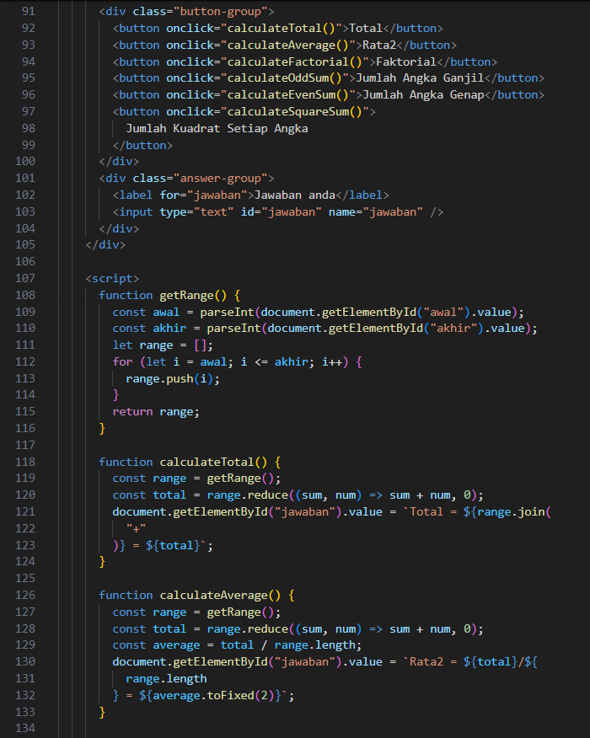

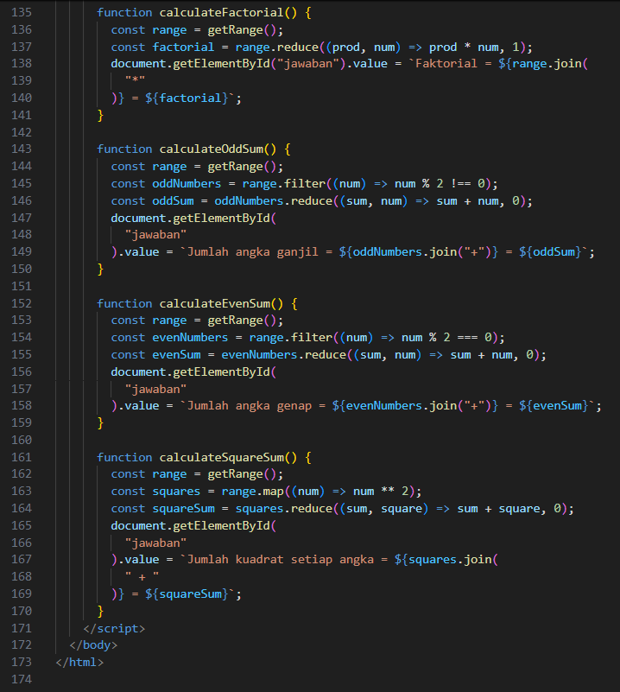

b. Screenshoot Hasil

Soal 3

a. Source Code

b. Screenshoot Hasil

